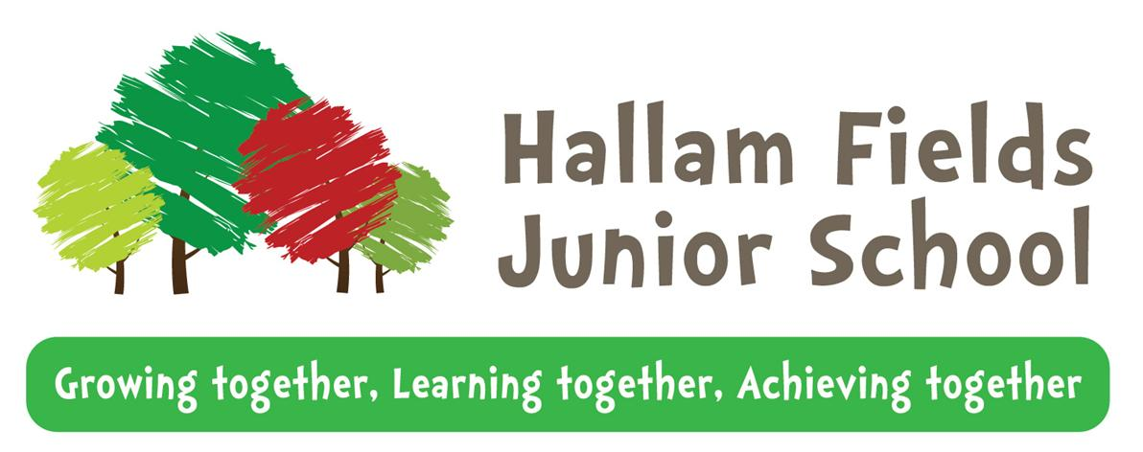

2024 - 2025

Pupil Premium policy

Hallam Fields Junior School

**2017 - 2018**

**At Hallam Fields, we value the opportunities for us to ‘*Grow together, learn together and achieve together’!* We aim to make all of our pupils confident, happy and motivated with a love of learning by providing a safe and welcoming environment, both indoors and outdoors, where our children can be challenged to do their best. We have high expectations of behaviour and achievement, recognising that all of our children bring something unique to the Hallam Fields team. Independence and collaboration are encouraged in equal parts and the whole school community is important in making this happen.**

**Our aim**

At Hallam Fields, we want children to be able to succeed and reach their potential regardless of background. Approximately 38% of our children attract Pupil Premium funding and this policy outlines how we will ensure it is spent to maximum effect.

**Background**

The Pupil Premium Grant was introduced in April 2011 by the Government to provide additional funding to address the gap in educational attainment and long-term economic well-being between socially disadvantaged children and young people compared to their peers. The reasons for this correlation are complex and no actual causal relationship has been proven. It was originally allocated to children from low-income families, who were known to be eligible for Free School Meals, and children who had been looked after continuously for more than six months. Eligibility for the Pupil Premium funding for 2012-2013 was extended to pupils who have been eligible for Free School Meals at any point in the last six years (known as the Ever 6 Free School Meals measure).

Schools also receive funding for children who have been adopted and a smaller amount for the children of service personnel.

|  |  |
| --- | --- |
| **Disadvantaged pupils** | **Pupil premium per pupil** |
| Pupils in year groups reception to year 6 recorded FSM | £1,480 |
| Pupils in year groups reception to year 6 recorded as Ever 6 FSM | £1,480 |
| Looked-after children (LAC) defined in the Children Act 1989 as one who is in the care of, or provided with accommodation by, an English local authority | £2,570 |
| Children who have ceased to be looked after by a local authority in England and Wales because of adoption, a special guardianship order, a child arrangements order or a residence order | £2,570 |
| **Service children** |  |
| Pupils in year groups reception to year 11 recorded as Ever 5 Service Child or in receipt of a child pension from the Ministry of Defence | £340 |

**Context**

When making decisions about using Pupil Premium funding it is important to consider the context of the school and subsequent challenges faced. The Covid 19 pandemic continues to have a negative impact for some of our children and families and these are all considered when making decisions about the spending of the funding. Common barriers for Free School Meals children *can be:*

* Less support at home
* Weak language and communication skills
* Lack of confidence
* More frequent behaviour difficulties
* Attendance and punctuality issues

There may also be complex family situations that prevent children from flourishing. The challenges are varied and there is no ‘one size fits all’ approach.

Schools are free to spend the Pupil Premium as they see fit. However, we will be accountable for how we have used the additional funding to support pupils eligible for the Pupil Premium Grant through:

* National performance data which compares disadvantaged pupils with their peers
* The Ofsted inspection framework, under which inspectors focus on the attainment of pupil groups, in particular those pupils who receive Pupil Premium funding.
* The reports for parents that we publish on the school website.

In making provision for socially disadvantaged pupils, we recognise that not all pupils who are eligible for free school meals, or who have been eligible in the last six years, are socially disadvantaged and further, some children who experience disadvantaged backgrounds are not eligible for free school meals and thereby do not attract Pupil Premium funding.

At Hallam Fields, we will ensure that all pupils will receive the highest quality of personalised provision that helps them to thrive regardless of their status as disadvantaged or non-disadvantaged.

**Key Principles**

By following the key principles below, we believe we can maximise the impact of our Pupil Premium spending.

We will provide a culture where:

* Quality first teaching has the greatest impact on pupil outcomes
* There are high expectations for all pupils
* Staff are expected to have professional conversations about the needs of individual pupils
* All staff are aware of who Pupil Premium children are, including those receiving the Ever 6 funding.
* We recognise that not all pupils who are socially disadvantaged are registered for Free School Meals.

**Analysing data**

We will ensure that:

* All staff are involved in the analysis of data so that they are fully aware of strengths and weaknesses of the children in their class, cohort and across the school.
* We use research to support us in determining the strategies that will be most effective.
* Data is collated and assessed each half term, with aspirational targets for learners.
* Children know their targets and can use these to focus on next steps to improve.
* Data is used to ensure that underachievement at all levels is targeted, not just lower attaining pupils.

**Identification of pupils**

We will ensure that:

* ALL teaching staff and support staff are involved in the analysis of data and identification of pupils.
* ALL staff are aware of who Pupil Premium and vulnerable children are.
* ALL Pupil Premium children benefit from the funding, not just those who are underperforming.
* Children’s individual needs are considered carefully so that we provide support for those children who could be doing ‘even better if...’ (Pupil Premium Profiles)

**Quality first teaching**

At Hallam Fields, we will continue to ensure that all children across the school receive good teaching with increasing percentages of outstanding teaching achieved by using our leaders and through professional development to:

* Ensure consistent implementation of the non-negotiables for planning, marking, targets and assessment.
* Set high expectations through aspirational targets
* Share good and better practice within the school and draw on external expertise.
* Provide high quality CPD
* Improve assessment through joint levelling and moderation across the year groups and with other schools.
* Ensure support staff are timetabled effectively to deliver in class quality support or recovery focussed intervention.
* Provide earlier identification and intervention.

**Personalised learning**

We will ensure that the additional support we provide is effective by:

* Looking at the individual needs of each child and identifying their barriers to learning – recorded on Pupil Premium profiles.
* Ensuring additional support staff and class teachers communicate regularly.
* Matching the skills of the staff and support staff to the interventions that they provide.
* Ensuring support from external agencies if required.
* Ensuring regular feedback to parents through parents’ evenings, phone calls home and formal / informal meetings.

**Monitoring and evaluation**

We will ensure that:

* A wide range of data is used – achievement data, pupils’ work, observations, learning walks and pupil voice.
* Assessment data is collected half-termly so that the impact of interventions can be monitored regularly.
* Interventions are adapted or changed if they are not working.
* Case studies are used to evaluate the impact of interventions.
* The Headteacher and business manager maintain an overview of Pupil Premium spending and a governor is given responsibility for Pupil Premium.

**Reporting**

We will report pupil premium via the strategy on the school website, through data analysis reports with both staff and governors, in governing body minutes and the Headteacher’s newsletter.

When reporting about pupil premium funding we will include:

1. Information about the context of the school
2. Objectives for the year

* Analysis of data
* Use of research and reasons for decision making from sources such as Sutton Trust, Education Endowment Foundation and the DfE.

1. Nature and support of allocation

* Learning in the curriculum
* Social, emotional and behavioural issues.
* Enrichment beyond the curriculum

1. An overview of spending

* Total pupil premium grant received
* Total pupil premium grant spent
* Total pupil premium grant overspend/under spend

1. A summary of the impact of pupil premium grant

* Performance of disadvantaged pupils compared to national non-pupil premium comparisons.
* Other evidence. E.g. external reviews, Ofsted
* Case studies
* Implications for pupil premium spending the following year.

The Governing Body will consider the information provided and will ensure that there is an annual statement to parents on the school website outlining how the Pupil Premium funding has been used to address the issue of closing the gap for pupils eligible for Pupil Premium. This task will be carried out in line with the requirements published by the Department for Education.

**Support for our families at Hallam Fields Junior School**

**The Pupil Premium Lead at Hallam Fields Junior School is Mrs Sarah Carr. Should you have any queries, please don’t hesitate to get in contact on 01159 322568 or email** [**mrscarr@hallamfields.derbyshire.sch.uk**](mailto:mrscarr@hallamfields.derbyshire.sch.uk)

**To complete a Free School Meal application for your child/children, please follow the link below. Derbyshire County Council will send you a letter within a week of you filling out the online application to let you know the outcome. Your child or children can then get their free school lunch straight away and your application will last throughout the entire school life of your children.** [**Free School Meals**](https://caya-apps.derbyshire.gov.uk/Synergy/SynergyWeb/Enquiries/Citizen/FreeSchoolMeals.aspx)

**If you would like further details or support completing the application, please contact the school office on 01159 322568 or speak to a member of staff on the school gate each morning.**

**Thank you.**

**This policy will be reviewed annually.**

**Date created: December 2024**

**Date of next review: December 2025**